October 11, 2019
Agapitus Iboro and Trien Hong
LEGACY LENDING LIBRARY
Executive Summary

LEGACY LENDING LIBRARY
Executive Summary
This database contains certain ways in which a library keeps track of the on goings in its facility. The database will be used to generate several reports. Using queries, we will be able to answer questions that arise. We will do this by running the queries against the database which will in turn give us visual representations of the query.
The implementation of the database contains 7 tables. These tables provide information about our books, libraries, and customers. The database tables include the following: Library, Collections, Books for sale, Books Checked out, Penalty, and Members. These tables represent the main entities of the application and contain links that define the relationships between each entity.
The information in the table Library includes the library ID, the name of the library, the city, street, state and zip code the library resides in, the email and phone number to contact the library and hours-of-operation. The purpose of library table is to hold and describe our in-house libraries. Attributes defining collection are as follows: ID, title, author, genre, page number, year published, publisher, and sale. The purpose of collection is to describe the genre of books. Attributes defining books-for-sale are as follows: BFS-ID and price. The purpose of this table is to describe books for sale. Attributes defining Books-Checked-out are: BCD-ID, date-checked-out, date-to-be-returned and date-returned. The purpose of the table books checked out is to keep track of the books checked out. Attributes defining Penalty are as follows: penalty ID, and fee. This table is a product of books not returned on the proposed date when checked out. Lastly, we have the Members table. Attributes defining members table are as follows member ID, first and last name, street, city, state, zip code, email, and phone. The purpose of this table is to describe and keep track of the customers associated with this library.

Changes made
- We took out the neighboring library table as that was redundant.

- We made the relationship between Members table and Books for sale, and Members and Books check out both non identifying as they are both strong entities that can exist on its own.

- We added the column title to Books for sale and Books check out table as you need to know the name of the book sold and the book checked out.

LEGACY LENDING LIBRARY
Database model

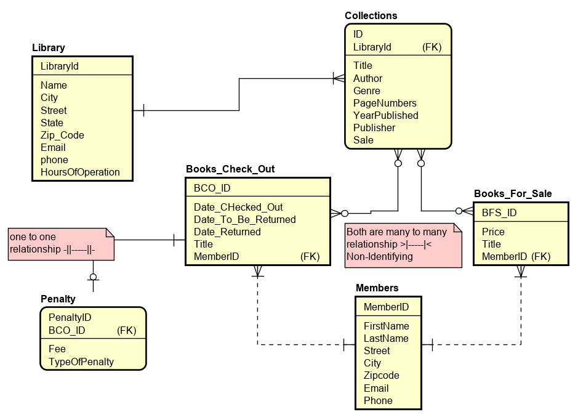

LEGACY LENDING LIBRARY
Schema
- LIBRARY (Library ID, Name, City, Street, State, Zip Code, Email, Phone, Hours of Operation)
- COLLECTIONS (ID, Title, Author, Genre, Page Numbers, Year Published, Publisher, Sale, Library ID)
FK Library ID LIBRARY
- MEMBERS (Member ID, First Name, Last Name, Street, City, Zip Code, Email, Phone)
- BOOKS_FOR_SALE (BFS ID, Price, Title, Member ID)
FK Member ID MEMBERS
- BOOKS_CHECK_OUT (BCO ID, Date Checked Out, Date to be Returned, Date Returned, Title, Member ID)
FK Member ID MEMBERS
- PENALTY (Penalty ID, Fee, Type of Penalty, BCO ID)
FK BCO ID BOOKS_CHECK_OUT

LEGACY LENDING LIBRARY
DATABASE DESIGN
(ER diagram)

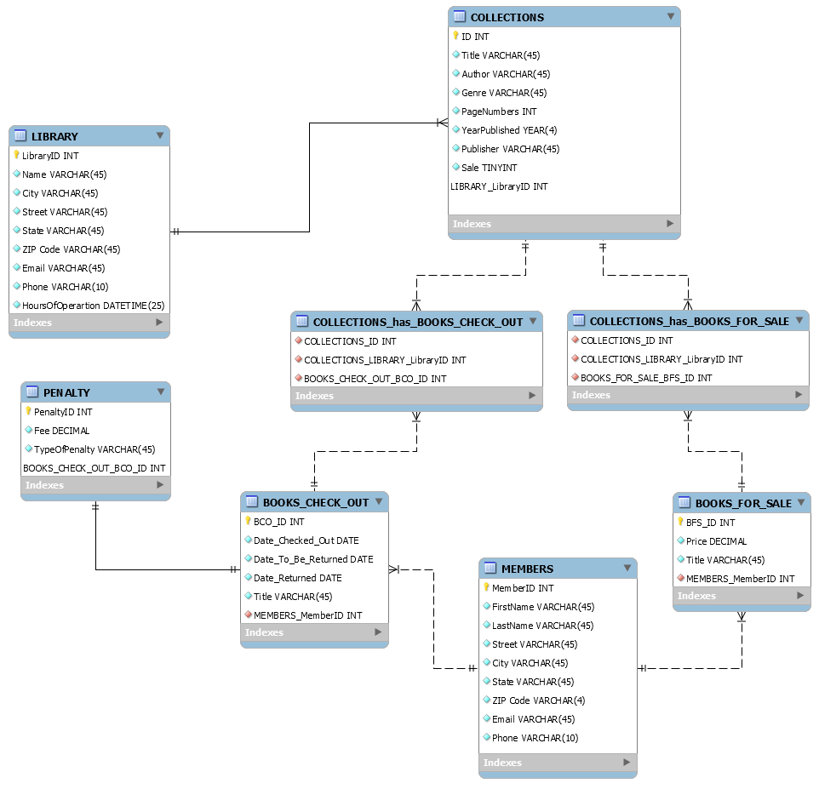

LEGACY LENDING LIBRARY
Schema
- LIBRARY (Library ID, Name, City, Street, State, Zip Code, Email, Phone, Hours of Operation)
- COLLECTIONS (ID, Title, Author, Genre, Page Numbers, Year Published, Publisher, Sale, Library ID)
FK Library ID LIBRARY
- MEMBERS (Member ID, First Name, Last Name, Street, City, Zip Code, Email, Phone)
- COLLECTONS_HAS_BOOKS_CHECK_OUT (Collections ID, Collections Library Library_ID, Books Check out BCO ID)
FK Collections ID COLLECTIONS
FK Collections Library Library_ID COLLECTIONS
FK Books Check out BCO ID BOOKS_CHECK OUT
- COLLECTIONS_HAS_BOOKS-FOR_SALE (Collections ID, Collections Library Library_ID, Books for sale BFS ID)
FK Collections ID COLLECTIONS
FK Collections Library Library_ID COLLECTIONS
FK Books for sale BFS ID BOOKS_FOR_SALE
- BOOKS_FOR_SALE (BFS ID, Price, Title, Member ID)
FK Member ID MEMBERS
- BOOKS_CHECK_OUT (BCO ID, Date Checked Out, Date to be Returned, Date Returned, Title, Member ID)
FK Member ID MEMBERS
- PENALTY (Penalty ID, Fee, Type of Penalty, BCO ID)
FK BCO ID BOOKS_CHECK_OUT

They are more tables in the database design than the database model because when a many to many relationship is created in workbench it creates an intersecting table.

Detailed Description on relationships, cardinalities and identifiers for both database design and database model

Library and Collections
- Relationship: the relationship between library and collections is one to many. This because collection can belong to only one library, while a library can have many collections. This is also an Identifying relationship because collection can’t exist without a library.
- Cardinalities
Library == The minimum cardinality here is one while the maximum is Many.
Collections == The minimum cardinality here is one while the maximum is one.
- Identifiers
Library == Library-ID
Collection == ID, Library-library-id

Collections and Books for Sale
- Relationship: the relationship between collections and books-for-sale is many to many. This is because many books can be sold from many and a collection can have many books sold which belong to many collections. It is a non-Identifying relationship. This is because they are both strong entities meaning they can exist without the other. It also has an intersecting table collection-has-books-for-sale with its identifiers.
- Cardinalities
Collections: Minimum cardinality is one while maximum cardinality is one
Collections-has-books-for-sale: Minimum cardinality is one while maximum cardinality is many
Books-for-sale: Minimum cardinality is one and maximum cardinality is one.
Collections-has-books-for-sale: Minimum cardinality is one while maximum cardinality is many
- Identifiers
Collections: ID, Library-library-id
Books-for-sale: BFS-ID, Member-member-id
Collections-has-books-for-sale: collection-id, collection-library-library-id, books-for-sale-BFS-id

Collections and Books Checked out
- Relationship: The relationship between collections and books-checked-out is many to many. This is because books can be checked out from many collections while many books checked out can belong to many collections. It is a non-identifying relationship because they are both strong entities meaning they can exist without the other.
- Cardinalities
Collection: Minimum cardinality is one while maximum cardinality is one
Collections-has-books-check-out: Minimum cardinality is one while maximum cardinality is many
Books-check-out: Minimum cardinality is one and maximum cardinality is one.
Collections-has-books-check-out: Minimum cardinality is one while maximum cardinality is many
- Identifiers
Collections: ID, Library-library-id
Books-check-out: BCO-ID, Members-member-id.
Collections-has-books-check-out: collection-id, collection-library-library-id, books-check-BCO-id.

Books Checked out and Penalty
- Relationship
The relationship here is one to one. This is because a book returned on a wrong date will warrant a specific penalty, and panalties can only belong to a certain book checked out. This is an identifying relationship because penalty is a weak entity that depends on books-check-out.
- Cardinalities
Books-check-out: minimum cardinality one maximum many
Penalty: minimum cardinality one maximum one.
- Identifiers
Books-check-out: BCO-ID, Members-member-id
Penalty: Penalty- id

Books for Sale and Members
- Relationship: the relationship between books for sale and member is one to many. This is because one specific copy of a book can only be sold to one member, while a member can buy man books. It’s a non-identifying relationship this is because they are both strong entities meaning they can exist without the other.
- Cardinalities
Books-for-sale: minimum is one maximum one
Members: minimum is one maximum many
- Identifiers
Books-for-sale: BFS-ID, Member-member-id
Members: member-ID

Books Checked out and Members
- Relationship: the relationship between books checked out and members is one to many. This is because a book can only be checked out by one member while one member can check out many books. It’s a non-identifying relationship this is because they are both strong entities meaning they can exist without the other.
- Cardinalities
Books-check-out: minimum cardinality one maximum one
Member: minimum cardinality one maximum many
- Identifiers
Books-check-out: BCO-ID, Members-member-id
Members: member-ID

Changes Made for deliverable 3
- COLLECTIONS (ID, Title, Author, Genre, Page Numbers, Year Published, Publisher, Sale, Library ID)
FK Library ID LIBRARY

- Took out SALE column from collections table
- Took out Type_of_Penalty column from Penalty table
- Some data types were changed
Hours of operation was changed from Date time to Varchar (50).
Varchar datatypes in the database were changed from holding a value of 45 to 50, only the Title columns were increased to 80.
Price was changed from decimal to decimal (15,2)
Fee also was changed from decimal to decimal (15,2).

LEGACY LENDING LIBRARY
Table and Query Implementation (Deliverable 3)

Query 1

This shows the name of our drama books from collections with page number more than 500

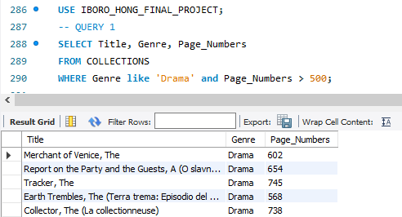

Query 2

This shows our libraries sorted by their names in ascending order

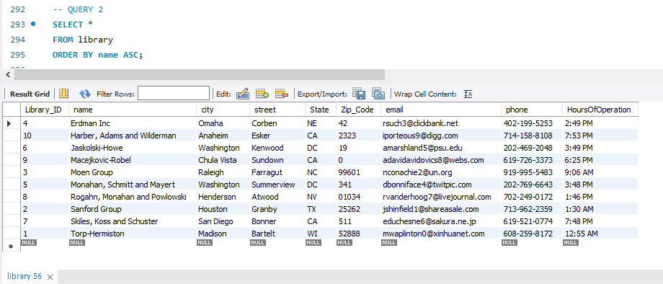

Query 3

This query shows our most expensive book

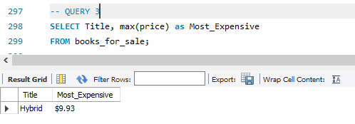

Query 4
This shows the id , phone numbers and name of members who bought a book priced over
$9.00 and checked out a book in the year 2019

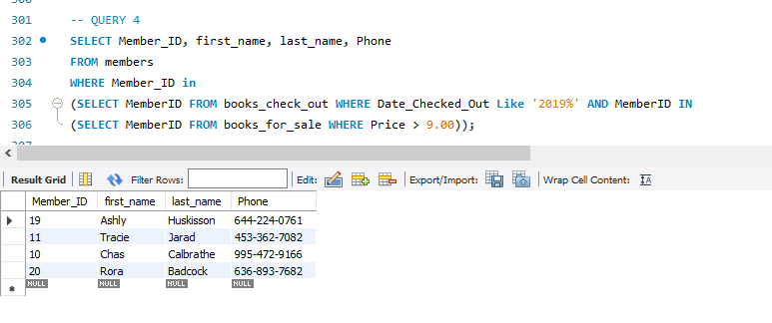

Query 5

This query shows when books were due, when they were returned and the individuals who returned it.
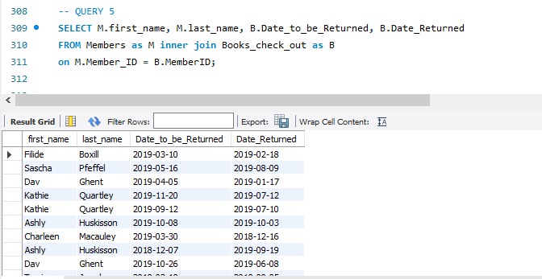

Query 6
A Visual representation of our prices if we increased prices by $5.00
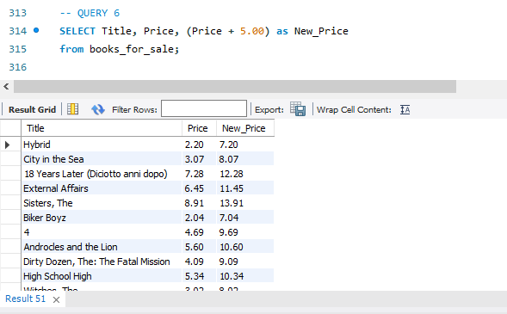

Query 7
This shows the first name and last name of our members who checked out our books and who has the most of our books
